Landing Page, to remain as-is

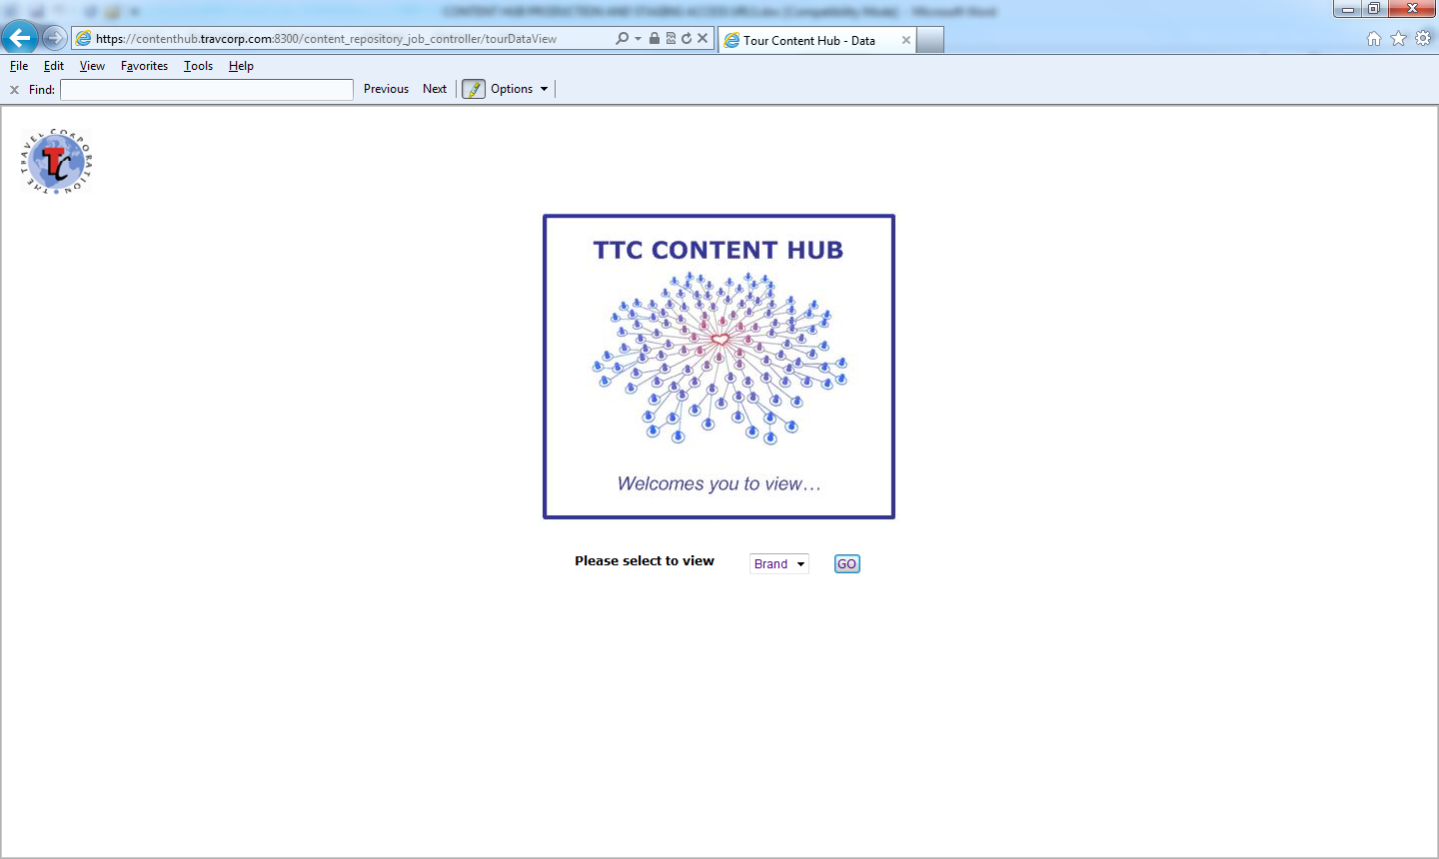
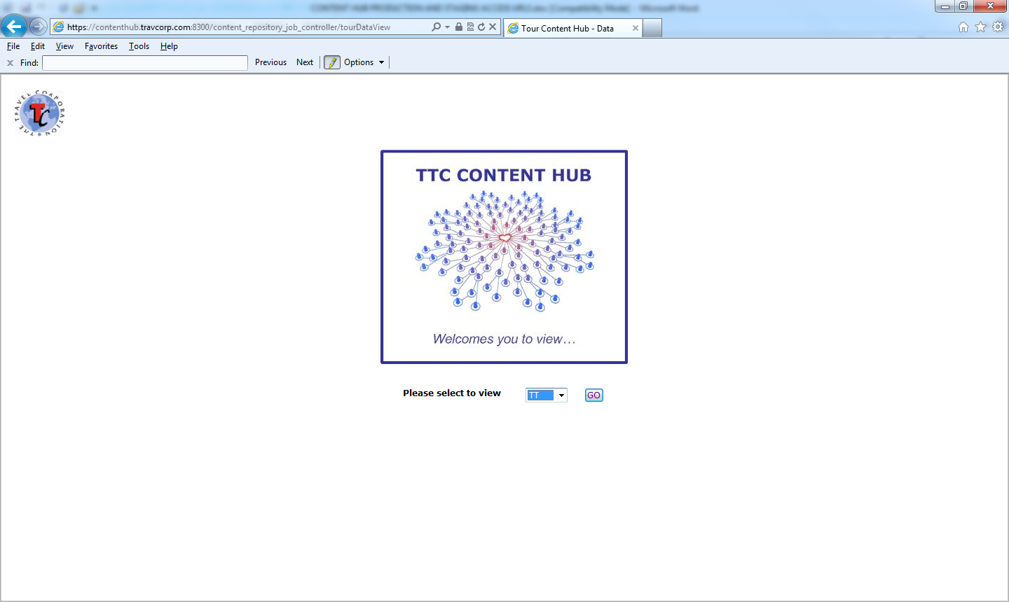

Selected brand’s tour list page to remain as-is
Aside from the small column heading naming change shown below

Change naming to ‘Tour Code’

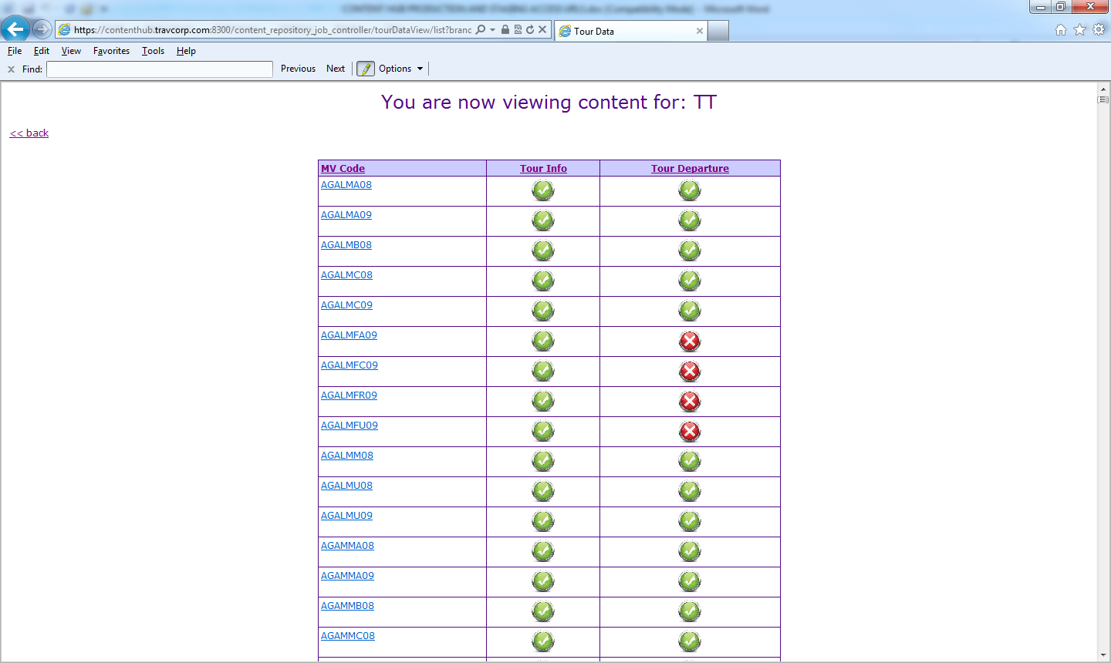

For a selected tour code, window is opened with full tour data details for that tour based on file(s) present for that tour.

Tour Info

Tour Info data display for each tour for which there is tour info file present for the brand.

Instead of displaying old version files element/attribute field names and value populations,
the requirement is to prettily display via html the new enahnced version Tour Info v3.0 tour info files data element and attribute namings and associated values, based on the new enhanced tour info files provisions wherever there is a tour info file present in the repository for the selected Tour Code for the selected Brand.

If an optional element /attribute in the schema is not present at all in the file, then for the tour info display that optional element/attribute would not be expected to be displayed, ie for tour info just display what is present in the tour info file.

Tour Departures

For the Tour Departures data display for each tour,

Instead of displaying old version files element/attribute field names and value populations,
the requirement is to prettily display via html the new enahnced version Tour Departures files data element and attribute namings and associated values, based on the new enhanced tour departures files provisions wherever there is a tour departures file present in the repository for the selected Tour Code.

If an optional element /attribute in the schema is not present at all in the file, still display the element as a field as it were in the display too, but empty of any value population, as for brand web content producers / more business-type folk easier for them to see one consistent display thans ometime with and sometimes without ‘fields’.

Based on the latest tour departures.2.5.4 schema (absolute final version shall be named 3.0),
the following represents how the new data could be displayed, replacing older version presentation,
and a presentation like the below would be accepted as meeting requirements:

TourCode: ESUPPCU209

TourName: European Supreme with Rhine Cruise Premium (with Eurostar) (Starts London) (Summer 2015) NOT REAL

TourInfo

BrandCode | TT
CMSId | TT_WEB_2
CMSTourId | 700512ABC
Duration | 12
TourCode | ESUPPCU209
TourName | European Supreme with Rhine Cruise Premium (with Eurostar) (Starts London) (Summer 2015) NOT REAL
CataloguedTour  Code  Name | ESUPM  European Supreme

SellingCompanies

SellingCompanyCode TTUSAS

Currency Code | Brochure  Code | Brochure  Name | TermsAndConditions  LinkURL | TourCategories |  | MarketingFlags
USD | TEUUS15F | Europe & Britain 2015 | https://book.trafalgartours.com/BookingWizard/SupplementalPages/TandC.aspx?sc=TTUSAS | CategoryName | CategoryValue | MarketingPriority 1
 | TEUUS15C | CostSaver 2015 |  | TourStyles | Premium Discovery | MostPopular true
 |  |  |  |  | Family Experiences
 |  |  |  |  | Guided Vacations | KeywordsPhrases Text
 |  |  |  |  |  | river cruises
 |  |  |  | ExperienceType | Spectacular Scenery | cruising
 |  |  |  |  | History | boat
 |  |  |  |  |  | culture
 |  |  |  | LocationType | Historical Interest | European culture
 |  |  |  |  |  | cultural
 |  |  |  | AccommodationType | Superior | luxurious
 |  |  |  |  |  | families
 |  |  |  |  |  | suitable for children
 |  |  |  |  |  | England
 |  |  |  |  |  | Parisian
 |  |  |  |  |  | Holland

SellingCompanyCode TTCANS

Currency Code | Brochure  Code | Brochure  Name | TermsAndConditions  LinkURL | TourCategories |  | MarketingFlags
CAD | TEUUS15G | Europe & Britain 2015 | https://book.trafalgartours.com/BookingWizard/SupplementalPages/TandC.aspx?sc=TTCANS | CategoryName | CategoryValue | MarketingPriority 3
 |  |  |  | TourStyles | First Class Discovery | MostPopular false
 |  |  |  |  | Family Experiences
 |  |  |  |  | Guided Holidays | KeywordsPhrases Text
 |  |  |  |  |  | river cruises
 |  |  |  | ExperienceType | Spectacular Scenery | cruising
 |  |  |  |  | History | boat
 |  |  |  |  |  | culture
 |  |  |  | LocationType | Historical Interest | European culture
 |  |  |  |  |  | cultural
 |  |  |  | AccommodationType | Time Out | luxurious
 |  |  |  |  |  | premier
 |  |  |  |  |  | families
 |  |  |  |  |  | family friendly
 |  |  |  |  |  | suitable for children
 |  |  |  |  |  | England
 |  |  |  |  |  | Parisian
 |  |  |  |  |  | Holland

TourVariationDefiners

OperatingProduct
 | Code | TEESUPPC09
 | ContractingSeason | Summer 2015
 | Category | Modular
 | Classification | Europe Discoveries
 | StandardName | First Class
IncludedSubProducts
 | IncludedSubProduct
 |  | Code | Name |  | Category |  |  | ServiceType
 |  | TEURSS9 | Eurostar Train Paris to London |  | TrainTicket |  |  | Eurostar Paris to London One Way
 |  | THSPA9S | Transfer Hotel to Station |  | Service |  |  | Transfer Hotel to Station
 |  | TSHLO9S | Transfer Station to Hotel |  | Service |  |  | Transfer Station to Hotel
RoomTypes
 | RoomType
 |  | Type | Sellable
 |  | Single | true
 |  | Twin | true
 |  | TwinShare | true
 |  | Triple | true
 |  | TripleShare | true
 |  | Quad | false
 |  | QuadShare | false

StartCity | Name | London
 | Airports | Airport
 |  | IATACode | Name | City | Region | Country | DefaultForCity
 |  | LCY | London London City Airport | London | City of London | United Kingdom | false
 |  | LGW | London Gatwick Airport | London | City of London | United Kingdom | false
 |  | LHR | London Heathrow Airport | London | City of London | United Kingdom | true
 |  | LTN | London Luton Airport | London | City of London | United Kingdom | false
 |  | STN | London Stansted Airport | London | City of London | United Kingdom | false
EndCity | Name | London
 | Airports | Airport
 |  | IATACode | Name | City | Region | Country | DefaultForCity
 |  | LCY | London London City Airport | London | City of London | United Kingdom | false
 |  | LGW | London Gatwick Airport | London | City of London | United Kingdom | false
 |  | LHR | London Heathrow Airport | London | City of London | United Kingdom | true
 |  | LTN | London Luton Airport | London | City of London | United Kingdom | false
 |  | STN | London Stansted Airport | London | City of London | United Kingdom | false

IsTourPackage | false
IncludedCruiseCabinType | Premium
AdditionalDefiners
 | Section
 |  | Title | spare for future use if needed
 |  | Text | spare for future use if needed

ContinentsVisited
CountriesVisited
LocationsVisited

Continent |  |  | Country |  |  |  |  | Location
 | Code | Name |  | Code | Name | ContinentCode |  |  | CountryCode | Name
 | EURO | Europe |  | GB | UnitedKingdom | EURO |  |  | GB | London
 |  |  |  | NL | Netherland | EURO |  |  | NL | Amsterdam
 |  |  |  | DE | Germany | EURO |  |  | DE | Heidelberg
 |  |  |  | FR | France | EURO |  |  | DE | Mannheim

Description

Take the Supreme European tour and spend an amazing time exploring 4 countries! See the White Cliffs of Dover, friendly Amsterdam and the romantic Rhine Valley. Experience the glamour and gastronomy of France!

Assets

Images

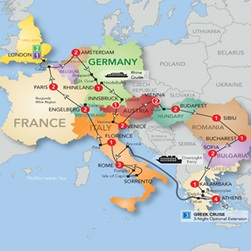

Name: route_map
Caption: caption of brand choosing
Width: 297
Height: 297
Type: map
url: http://www.trafalgar.com/%7e/media/TT/ProductImages/First%20Class%202013%20-%20US%20-%20Eurostar/ESUPC_WIN_MAP_US_13.ashx?mw=297&amp;mh=297&amp;bc=white

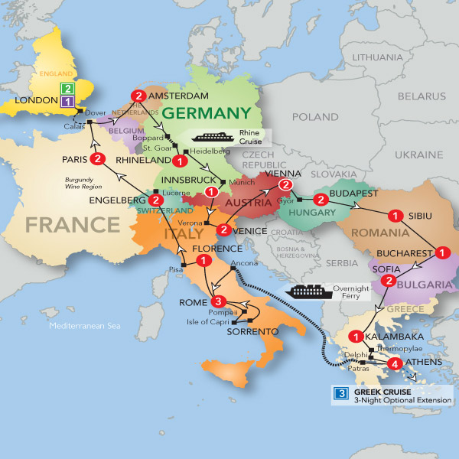
Name: route_map
Caption: caption of brand choosing
Width: 600
Height: 600
Type: map
url: http://www.trafalgar.com/%7e/media/TT/ProductImages/First%20Class%202013%20-%20US%20-%20Eurostar/ESUPC_WIN_MAP_US_13.ashx

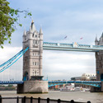
Name: primary_image
Caption: caption of brand choosing
Width: 125
Height: 125
Type: photo
url: http://www.trafalgar.com/tours/~/media/tt/consumer/search/search%20result%20photos/ESUPM_125x125_001.ashx

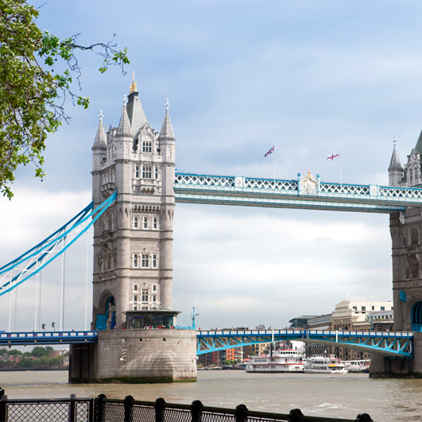
Name: primary_image
Caption: caption of brand choosing
Width: 531
Height: 531
Type: photo
url: http://www.trafalgar.com/tours/~/media/tt/consumer/search/search%20result%20photos/ESUPM_531x531_001.ashx
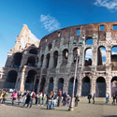
Name: secondary_image
Caption: caption of brand choosing
Width: 125
Height: 125
Type: photo
url: http://www.trafalgar.com/tours/~/media/tt/consumer/search/search%20result%20photos/ESUPM_125x125_002.ashx

Name: secondary_image
Caption: caption of brand choosing
Width: 531
Height: 531
Type: photo
url: http://www.trafalgar.com/tours/~/media/tt/consumer/search/search%20result%20photos/ESUPM_2_531x531_002.ashx

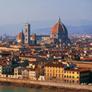
Name: third_image
Caption: caption of brand choosing
Width: 125
Height: 125
Type: photo
url: http://www.trafalgar.com/tours/~/media/tt/consumer/search/search%20result%20photos/ESUPM_125x125_003.ashx

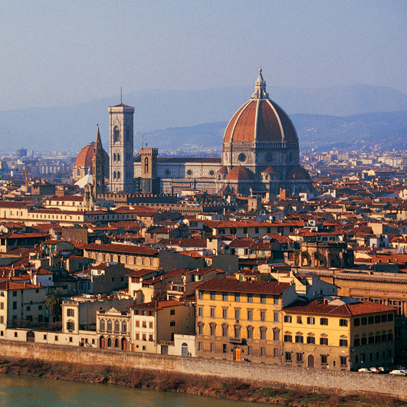
Name: third_image
Caption: caption of brand choosing
Width: 125
Height: 125
Type: photo
url: http://www.trafalgar.com/tours/~/media/tt/consumer/search/search%20result%20photos/ESUPM_2_531x531_003.ashx

Name: logo_image
Caption: Trafalgar Vacations logo for USA selling market
Width: 80
Height: 40
Type: logo
url: http://www.trafalgar.com/logo/TTUSAS_125x125_001.ashx

Name: logo_image
Caption: Trafalgar Vacations logo for USA selling market
Width: 80
Height: 40
Type: logo
url: http://www.trafalgar.com/logo/TTCANS_125x125_001.ashx

Videos

Name: primary_video
Caption: See the World From the Inside with Trafalgar
AspectRatio: 4:3
Type: video
url: http://www.youtube.com/watch?v=HpAH_nyDM4&list=UUNe_7_Zk1frNTPKxha3Y08w&index=14&feature=plcp

Name: secondary_video
Caption: Family Experiences with Trafalgar
AspectRatio: 16:9
Type: video
url: http://www.youtube.com/watch?v=OpZV5ksc4Uo&feature=plcp

ItinerarySegments

StartDay 1 Duration 1 Title DEPART USA

Text Overnight flight to London

StartDay 2 Duration 1 Title ARRIVE LONDON (2 NIGHTS)

Text Welcome to London! Relax or spend time exploring this fascinating city.

Accommodation Hilton Kensington (Superior First Class)

LocationsVisited
Location
CountryCode Name
GB London

StartDay 3 Duration 1 Title LONDON SIGHTSEEING AND FREE TIME

Text See the famous sights including Big Ben, the Houses of Parliament and
Buckingham Palace on your included half day sightseeing tour with a
Local Guide. The rest of your day is free for shopping or exploring.

Accommodation Hilton Kensington (Superior First Class)

Meals
Meal
Type Number
Full Breakfast 1

LocationsVisited
Location
CountryCode Name
GB London

StartDay 4 Duration 1 Title LONDON - AMSTERDAM (2 NIGHTS)

Text Cross the channel by ferry to France and then on to Amsterdam. Enjoy splendid views from your glass-topped boat as you cruise along the city’s canals. Join your fellow travellers and Travel Director for a Welcome Reception dinner.

Accommodation Mercure Aan De Amstel (First Class)

Meals
Meal
Type Number
Buffet Breakfast 1
Welcome Dinner Reception 1

LocationsVisited
Location
CountryCode Name
NL Amsterdam
GB London

StartDay 5 Duration 1 Title AMSTERDAM SIGHTSEEING AND FREE TIME

Text Amsterdam boasts art, architecture, canals, museums, bicycles and charming side streets. During an
orientation see the Mint Tower, Dam Square and Museum Square. Visit a historic diamond polishing factory
to see the diamond cutters at work. Visit Zaanse Schans where a Local Expert demonstrates the making of
wooden clogs and Dutch cheese.

Accommodation Mercure Aan De Amstel (First Class)

Meals
Meal
Type Number
Buffet Breakfast 1

LocationsVisited
Location
CountryCode Name
NL Amsterdam

OptionalExtras

Extra  Code | Section  Title |  |  |  | Text
AMST07 | DINNER IN AN HISTORIC DUTCH HOUSE |  |  |  | Savour a meal of Dutch specialities in elegant surroundings. Drinks included.
Price
Passenger  Type |  | Currency  Code | Amount  From | Amount  To |  | Notes
Adult |  | EURO | 61.00 | 68.00 |  | Section  Title | Text
 |  |  |  |  |  | Pricing Information | EURO 68.00 for party size 20-34 people / EUR0 61.00 for party size 35 or more people.
Optional excursions are priced in the local currency of the destination.

You can choose if you wish to take an optional excursion when you are on your trip, via your Tour Director in the visited region, and these can be paid with cash or credit card.
StartDay 6 Duration 1 Title AMSTERDAM - RHINE CRUISE - HEIDELBERG - MANNHEIM

Text Today travel to Boppard for a cruise along the Rhine. Stop in Heidelberg to view the magnificent castle
ruins. Dine tonight at your hotel.

Accommodation Grauer Baer (First Class)

Meals
Meal
Type Number
Buffet Breakfast 1
Dinner 1

LocationsVisited
Location
CountryCode Name
NL Amsterdam
DE Heidelberg
DE Mannheim

StartDay 7 Duration 1 Title MANNHEIM-PARIS

Text See the vineyards en route to Paris.

Accommodation Pullman La Defense (Superior First Class)

Meals
Meal
Type Number
Buffet Breakfast 1

LocationsVisited
Location
CountryCode Name
DE Heidelberg
FR Paris

OptionalExtras

Extra  Code | Section  Title |  |  |  | Text
PART24 | MOULIN ROUGE CABARET AND DINNER |  |  |  | Dinner and Cabaret, including wine and champagne, at the world famous Moulin Rouge.
Price
Passenger  Type |  | Currency  Code | Amount  From | Amount  To |  | Notes
Adult |  | EURO | 150.00 | 150.00 |  | Section | Text
 |  |  |  |  |  |  | This optional evening excursion to the Moulin Rouge Cabaret is for adult guests over the age of 18.
Optional excursions are priced in the local currency of the destination.

You can choose if you wish to take an optional excursion when you are on your trip, via your Tour Director in the visited region, and these can be paid with cash or credit card.

StartDay 8 Duration 3 Title PARIS SIGHTSEEING AND FREE TIME

Text Enjoy an included visit up the Eiffel Tower to the second level with your Local Guide. Drive along the
Champs Élysées and see Notre Dame. Tonight, say ‘au revoir’ to your companions at a Farewell Dinner.

Accommodation Pullman La Defense (Superior First Class)

Meals
Meal
Type Number
Buffet Breakfast 2
Dinner 1

LocationsVisited
Location
CountryCode Name
FR Paris

OptionalExtras

Extra  Code | Section  Title |  |  | Text
PART02 | SEINE CRUISE AND PARIS BY NIGHT |  |  | Paris at night is a city transformed. Enjoy this superb 'city of light' as we take a leisurely cruise on the popular river boats under the bridges of Paris, admiring the wonderful buildings which adorn the banks of the River Seine. Afterwards, as we drive through this amazing city, we stop at some vantage points for you to capture these fascinating sights on camera. (In summer, this trip may take place before sunset).
Price
Passenger  Type |  | Currency  Code | Amount  From |  | Amount  To
Adult |  | EURO | 34.00 |  | 34.00
Child |  | EURO | 17.00 |  | 17.00

Extra  Code | Section  Title |  |  |  | Text
PART07 | VERSAILLES THE PALACE AND GARDENS |  |  |  | We leave the bustle of the city for the splendour of Versailles. Created by the “Sun King” Louis XIV, the palace became the envy of every other European ruler. Our guide takes us through the State apartments, including the famous Hall of Mirrors. Afterwards, take a stroll through the symmetrical tree-lined gardens. (NB. This optional is subject to availability)
Price
Passenger  Type |  | Currency  Code | Amount  From | Amount  To |  | Notes
Adult |  | EURO | 64.00 | 80.00 |  | Section  Title | Text
 |  |  |  |  |  | Pricing Information | Pricing depends on Season. April to June 2015, EURO 64.00 Per Adult / 32.00 Per Child. July to September 2015, EURO 80.00 Per Adult / EURO 40.00 Per Child.  A Discount of 10% is offered for Family party comprising 2 Adults and 2 Children. Child must be under 16 years of age at time of visit.
Optional excursions are priced in the local currency of the destination.

You can choose if you wish to take an optional excursion when you are on your trip, via your Tour Director in the visited region, and these can be paid with cash or credit card.
Child |  | EURO | 32.00 | 40.00

StartDay 11 Duration 1 Title PARIS - EUROSTAR - LONDON

Text You are transferred to Paris Gare du Nord train station where you board the Eurostar train to London.
The journey time to London St. Pancras International is 2 hours and 15 minutes. On arrival in London
you are transferred to your hotel.

Accommodation Thistle Euston (Superior First Class)

Meals
Meal
Type Number
Buffet Breakfast 1

LocationsVisited
Location
CountryCode Name
FR Paris
GB London

StartDay 12 Duration 1 Title LONDON- USA

Text Enjoy an English breakfast at the end of your vacation.

Accommodation Thistle Euston (Superior First Class)

Meals
Meal
Type Number
Buffet Breakfast 1

LocationsVisited
Location
CountryCode Name
GB London

WhatsIncluded

Title | Dining Highlights
Text | - 28 hot buffet breakfasts  - 15 evening meals including:  - Welcome Reception Canal Cruise and dinner with your Travel Director in Amsterdam.  - 9 three-course dinners.  - 1 three-course dinners with wine.  - 1 dinner on mini-cruise.  - Highlight Dinner with wine in Budapest.  - Highlight Dinner with wine in Rome.  - Farewell Dinner with wine in Paris.  - 9 cruise meals including:  - 3 cruise breakfasts.  - 3 cruise lunches.  - 3 cruise dinners.  - 15 evening meals:  - Welcome Reception Canal Cruise and dinner with your Travel Director in Amsterdam.  - 9 three-course dinners.  - 1 three-course dinners with wine.  - 1 dinner on mini-cruise.  - Highlight Dinner with wine in Budapest.  - Farewell Dinner with wine in Paris.
Title | First Class Travel Highlights
Text | - First Class hotel accommodation featuring two-bedded rooms and private facilities  - All hotel service charges and tips, baggage handling fees and local taxes  - Travel by luxury, air-conditioned coach with reclining seats and an on-board restroom  - The services of a professional Travel Director  - The services of a Trafalgar Local Host at your Trafalgar London hotel  - Use of Trafalgar’s London Reception Centre offering a range of services including tickets for day trips and local attractions  - Audio headsets to clearly hear your guide’s commentary on all included sightseeing  - A travel wallet with your documentation  - Complimentary keepsake photo and map  - Airport transfers are included on the arrival and departure days of your trip.
Highlights

Title | Sightseeing Highlights
Text | - London Morning sightseeing tour with a Local Guide includes view  - of Buckingham Palace, the Houses of Parliament, Westminster Abbey  - and Big Ben.  - Amsterdam Orientation includes the Mint Tower, Tower of Tears, Dam Square, and ‘Skinny Bridge’.  - Rhine Valley Cruise the Romantic Rhine.  - Heidelberg View the castle.  - Paris View Notre Dame Cathedral, the Arc de Triomphe, Champs Élysées and the Louvre. Enjoy spectacular city views from an included ascent to the second level of the Eiffel Tower.
AirportTransfers
Title | Travellers from USA
Text | At Trafalgar, we know how important it is to get your holiday off to a seamless and smooth start. That's why every part of your journey, from your front door to the start hotel of your chosen holiday, and from your hotel to the airport and back home again on your return, is made easy with Trafalgar.  Airport transfers for North America  With Trafalgar you will receive complimentary arrival and departure transfers by scheduled shuttle, minivan or taxi between designated airports and Trafalgar hotels on the scheduled starting and ending day of your guided vacation only. Passengers arriving before or leaving after the scheduled itinerary day may book and buy a transfer through Trafalgar providing that they also purchase the additional pre and post itinerary hotel night(s) from Trafalgar. When booking extra night(s) accommodation, you will also have the opportunity to book the relevant transfer service(s).  Airport transfers in Europe  All Trafalgar guests receive complimentary arrival and departure transfers by shuttle bus on the arrival and departure day of their guided vacation at the times specified below. Any guests whose flight times do not coincide with the shuttle bus transfer timings may choose to book and purchase a transfer. Additionally, guests arriving before or leaving after the scheduled vacation may also book and buy a transfer through Trafalgar providing that they also purchase the additional pre and post trip hotel night(s) from Trafalgar.  Eastern Mediterranean  Trafalgar is pleased to offer complimentary airport transfers at any time either on the first or last day of the itinerary or on other days in conjunction with pre and post accommodations booked through Trafalgar. Note that flight times must be provided to Trafalgar no fewer than 21 days before flight departure.  Etc… etc…
Notes

Title | Travellers from USA
Text | Any special notes for travellers eg You will need special Visa X.

AdditionalInfo

Title | SomeText
Text | SomeText

Tour Departures Data
TourCode: | ESUPPCU209 |  | OperatingProductCode: TEESUPPC09
 |  |  | OnlineBookable: | true
SellingCompanyCode: |  | TTUSAS | InventoryBrochureCode: TEUUS15F
Departure: 1
DepartureCode | StartDateTime | EndDateTime | AvailabilityStatus | DefiniteDeparture | DateRange  IncludesTravelTime | CanSearchForFlights | IsEligibleForFrequent  TravellerDiscount |  | Notes
06C14a | 2014-03-06T00:00:00 | 2014-03-18T00:00:00 | Available | false | true | true | true |  | Some important notes about this tour departure for you.
Departure Pricings
CurrencyCode | PriceIsIndicative
USD | false
Sellable Room Type | AdultBasePrice | AdultCombinedPrice | ChildBasePrice | ChildCombinedPrice | Room OccupancyRule
 |  |  |  |  | Maximum  Adults | Maximum  Passengers | Minimum  Adults |  | Minimum  Passengers | Minimum  PayingAdults |  |  | Adult  AgeFrom | Adult  AgeTo | Child  AgeFrom | Child  AgeTo
Single | 2865.00 | 3020.00 | 2325.00 | 2480.00 | 1 | 1 | 1 |  | 1 | 1 |  |  | 18 | 99 | 5 | 17
Twin | 2325.00 | 2480.00 | 2325.00 | 2480.00 | 2 | 2 | 1 |  | 2 | 1
Triple | 2175.00 | 2330.00 | 2325.00 | 2480.00 | 3 | 3 | 1 |  | 3 | 2
CombinedIncludedCharges
Mandatory Miscellaneous Products |  |  |  |  | Surcharge /  PortTax /  FoodFund | AdultPrice | ChildPrice
Mandatory Miscellaneous ProductCode | Name | Category | AdultPrice | ChildPrice | Surcharge /  PortTax /  FoodFund | AdultPrice
CYU3TA8 | Intra Tour Air European Supreme | Intra Tour Air | 85.00 | 85.00 | Surcharge | 10.00 | 10.00
TLOUISC | Louis Cruise Information | Voucher Only | 00.00 | 00.00 | PortTax | 50.00 | 50.00
 |  |  |  |  | FoodFund | 10.00 | 10.00
Discounts

Discount Code | Type | Basis | Amount | IsPercentage | PaymentDueDate
98171 | EarlyPaymentDiscount | Per Passenger against their Room Price for the Tour Departure, if pay in full be the Early Payment Due Date. | 10 | true | 2012-10-05T00:00:00Z
Associated Products
Associated Accommodation Products
PreAccommodations
Code | Name | Room Type | AdultPrice | ChildPrice | Address Line1 | AddressLine2 | Address Line 3 |  | City |  | Region |  | PostCode | Country
TLOCHS9 | The Cumberland | Single | 284.00 | 284.00 | Great Cumberland Place | 1 Cumberland Lane | Westminster |  | London |  | City Of London |  | W1H 7DL | United Kingdom
TLOCHS9 | The Cumberland | Twin | 180.00 | 180.00 | Great Cumberland Place | 1 Cumberland Lane | Westminster |  | London |  | City Of London |  | W1H 7DL | United Kingdom
TLOCHS9 | The Cumberland | Triple | 175.00 | 175.00 | Great Cumberland Place | 1 Cumberland Lane | Westminster |  | London |  | City Of London |  | W1H 7DL | United Kingdom
PostAccommodations
Code | Name | Room Type | AdultPrice | ChildPrice | Address Line1 | AddressLine2 | Address Line 3 |  | City |  | Region |  | PostCode | Country
TLOCHS9 | The Cumberland | Single | 284.00 | 284.00 | Great Cumberland Place | 1 Cumberland Lane | Westminster |  | London |  | City Of London |  | W1H 7DL | United Kingdom
TLOCHS9 | The Cumberland | Twin | 180.00 | 180.00 | Great Cumberland Place | 1 Cumberland Lane | Westminster |  | London |  | City Of London |  | W1H 7DL | United Kingdom
TLOCHS9 | The Cumberland | Triple | 175.00 | 175.00 | Great Cumberland Place | 1 Cumberland Lane | Westminster |  | London |  | City Of London |  | W1H 7DL | United Kingdom
Associated Miscellaneous Products
Miscellaneous Product Code | Name | Category | AdultPrice | ChildPrice
TINUS36 | BerkelyCare Travel Protection for Packages over $3500 | Travel Protection | 249.00 | 249.00
TINUS16 | BerkelyCare Travel Protection for Packages under $2000 | Travel Protection | 129.00 | 129.00
TINUS26 | BerkelyCare Travel Protection for Packages from $2001 to $3500 | Travel Protection | 199.00 | 199.00
TG037S9 | Pre-Paid Gratuities | TD Tips | 199.00 | 199.00
Departure: 2
DepartureCode | StartDateTime | EndDateTime | AvailabilityStatus | DefiniteDeparture | DateRange  IncludesTravelTime | CanSearchForFlights | IsEligibleForFrequent  TravellerDiscount |  | Notes
03D14a | 2014-04-03T00:00:00 | 2014-04-15T00:00:00 | On Request | false | true | true | true |  | Some important notes about this tour departure for you.
Departure Pricings
Etc……for each departure of this selling company

And then follow with the departures details for the next Selling Company if a multi-selling company Tour

SellingCompanyCode: |  | TTCANS | InventoryBrochureCode: TEUUS15F
Departure: 1
DepartureCode | StartDateTime | EndDateTime | AvailabilityStatus | DefiniteDeparture | DateRange  IncludesTravelTime | CanSearchForFlights | IsEligibleForFrequent  TravellerDiscount |  | Notes
06C14a | 2014-03-06T00:00:00 | 2014-03-18T00:00:00 | Available | false | true | true | true |  | Some important notes about this tour departure for you.
Departure Pricings
CurrencyCode | PriceIsIndicative
CAD | false
Etc……for each departure of this selling company

